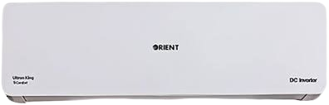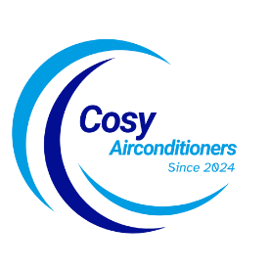

SKU: OSU-18HFCP/013USDC (W)

**1.5 Ton Ultron KING eComfort Silk White DC Inverter**

Rs 205,999.00 Rs 172,000.00

100 % Pure copper

Low voltage operation 70V

Auto Clean Sterilization System

With adoption of optimized cooling system, the cooling capacity of Haier Air Conditioners still could catch up 100% to provide the best cooling experience to user at 46◦C high temperature.

**THANK YOU!**

**Product details**

**WELLCOME TO OUR WEBSITE**